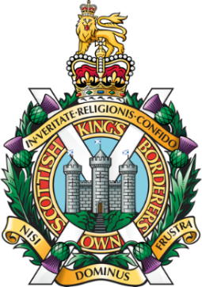
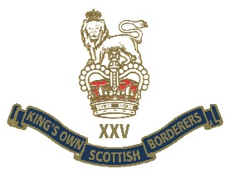
DEDICATED TO THE OFFICERS AND MEN OF
1ST BATTALION
THE KING’S OWN SCOTTISH BORDERERS
WHO SERVED IN NORTHERN IRELAND
1970 - 2006
AND TO THE ETERNAL MEMORY OF THOSE BORDERERS WHO LOST THEIR LIVES WHILST SERVING ON OPERATIONS

CSGT P D SINTON 28 07 70
LCPL P D SIME 07 04 72
LCPL J B R GOLD 25 04 72
SGT H S MIDDLEMASS 10 12 72
PTE J GILLIES 06 10 76
SGT H SHINGLESTON MM 25 11 76
PTE P B SCOTT 10 09 79
LCPL M J PATERSON 13 12 89
PTE J HOUSTON 13 12 89

