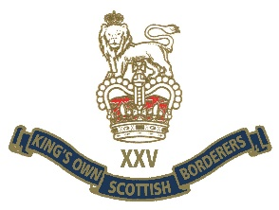
ASSOCIATION UPDATE as at 20 MAR 2020
Borderers,
As you will be well aware, the current situation with regards to the Corona Virus Pandemic is having an impact on all our lives.
The following points give details of the current state of our Regimental activities:
01 | Berwick Branch dinner 20 Mar | Postponed until further notice
02 | Kelso Races 24 may | Final decision 01 Apr likely to be postponed until next year
03 | Officers Club Golf 29 May | Final decision 01 Apr likely to be cancelled
04 | Ednam House Dinner 30 May | Final decision 01 Apr likely to be postponed until next year
05 | NI memorial dedication 20 Jun | No decision, most likely to be postponed
06 | Minden Golf 31 Jul | No decision likely to be cancelled
07 | Minden Parade 01 Aug | No final decision yet, likely to be reduced or cancelled
08 | Malaya dinner 03 Sept | Likely to be postponed

All of the above may be changed at short notice as Government direction develops. We must all remember that the safety of us all is the priority. All Borderers are asked to check on your “buddy”, many of us will fall into the “at risk” category. The President would rather see events postponed rather than risk our health.
All of our events can be rescheduled in the future. Any updates will be notified on the KOSB website, KOSB Association Facebook page and the Officers’ Club mailing list.
The Barracks site will remain closed by order of English Heritage however the KOSB office will be manned by the EXO during routine hours.
The President thanks all Borderers in advance for their cooperation during these challenging times.

ONCE A BORDERER ALWAYS A BORDERER

