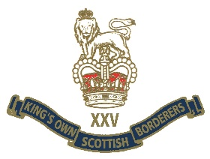

What a great thrill and pleasure for all Borderers to see that Erwin Ureel, ex Belgian army Warrant Officer, has been honoured by HM The Queen with an Honorary MBE for all he did for the King’s Own Scottish Borderers' remembrance in WW1.
This is aside from the many other British Units and Military organisations he helped and guided, (see Black Watch Corner for example) and the spectacular events he laid on in 2017, to mark the Passchendaele Centenary, near Zonnebeke, Belgium.
His unstinting hard work to achieve international recognition for the events of 1917, on his home soil, was marked in a very special way.

For the KOSB alone, he made our dream of creating a memorial to our 7055 fallen in World War 1 become a reality. He was the driving force and the conduit to the local civic powers, to allow us to erect our memorial on the Scottish memorial, at the site of the Frezenberg Redoubt , where our 7th Bn lost 300 men, but took the position, near Zonnebeke.
We are so thrilled with the result, and to see all our WW1 dead publicly and so prominently remembered.

He will receive his award from the British Ambassador at a ceremony in the Embassy in April.

We salute you Erwin MBE!

That's the 2nd MBE in a month for the Regimental family- including Jo Middlemiss for her work over many years in a remote part of Ethiopia!

On behalf of the President and all members of the KOSB Association we offer our sincerest congratulations.

