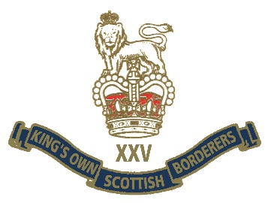
MINDEN CANCELLATION 2020
MESSAGE FROM THE PRESIDENT

Borderers,
Following the publication of the Government's guidance last week, and having examined the phasing of the planned exit from lockdown, I consulted the Regimental Trustees today with regards to Minden Day. It is clear that, despite the planned phasing, there are other factors to take into account, such as the readiness of English Heritage to allow the use of the Barracks, and uncertainty from both the Council and the local Constabulary over the ability to march through the town. If one adds into that mix the general age of our membership, the issues that may arise in terms of tentage, catering, refreshment, portaloos, etc, and perhaps a general reluctance to travel, all need to be considered.
The safety of all Borderers will always be a priority. Accordingly, and very reluctantly, the Trustees have decided to cancel the traditional Minden Day parade, march past and lunch at Berwick for 2020.
This is a sad step, especially as for the first time in several years it was due to fall on Saturday 1st August, but I do feel that it is the right thing to do in the circumstances, and I don't think this will come as a surprise to any Borderer. It is proposed, however, that we do what we can to commemorate our Regimental day as much as possible, and we will publish greetings from our Patron HRH The Princess Royal and the Minden Address on the website, plus invite Borderers to hold their own 'parade' in their garden, or under Branch arrangements’ much as you did for VE Day, remembering to adhere to official guidelines with regards to social distancing and travel. We very much hope to return to normal for Minden Day 2021.
“Once a Borderer always a Borderer”

