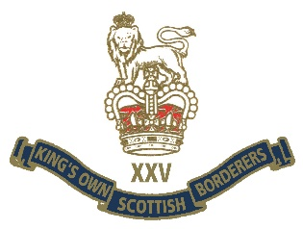
MINDEN DAY 2020
Borderers, as previously notified this year’s MINDEN DAY parade at Berwick was cancelled due to the current pandemic and the risk to us all.
This however will not stop us from commemorating our most famous Battle Honour and remember our forefathers who fought that day and the thousands of Borderers who have served and died since then.
“Mini Mindens” have been organised at the following locations by those shown:
BERWICK EXO/BILL HEANEY BERWICK BRANCH
EDINBURGH GRANT HORSBURGH/SID MUNRO EDINBURGH BRANCH
DUMFRIES RONNIE RAE/FRANK ROY DUMFRIES BRANCH
LIVINGSTON JOHN ROSS/GEORGE ROSS jnr
ST BOSWELL’S ANDREW HERBERTS
PERTH&KINROSS ANDY MIDDLEMISS
Those attending will be briefed by the relevant organiser with regards timings, location, dress and conduct.
For the majority of Borderers “Minden will be at home or in small groups, you are all encouraged to mark the day in a similar way to VE day by wearing your Bunnet, trews and medals at 1200 on Sat 1st Aug, please post photos on Facebook or send them to RHQ for publication in the Chronicle. RHQ will send copies of Minden address, HRH greetings and the Presidents greetings to organiser’s, they will also be posted on the KOSB website and Association facebook page.
It is likely many Borderers will still visit Berwick over that weekend, please be aware that you will not get access to the Barracks. The Minden will be held at 0900 as English Heritage are opening the Barracks site at 1000 to pre booked visitors with tickets only. The KOSB museum will remain closed due to the pandemic.
Wherever you commemorate Minden please remember yours and others safety, we have all commemorated Minden in far worse places whether it be Jungle, deserts or Belfast streets.
“ONCE A BORDERER ALWAYS A BORDERER”

