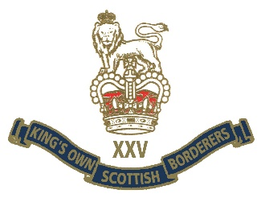
KOSB AGM 17 OCT 2020
Borderers,
Due to current pandemic restrictions and to maintain the safety of all Borderers, it has become necessary to postpone our Association Annual General Meeting (AGM) due to be held on Sat 17 Oct in Berwick.
While not totally unexpected this will be a disappointment to all Borderers. The President and Trustees will attempt to hold a video/zoom meeting in the near future with Branch Officials and as many others as can be accommodated satisfactorily on an electronic meeting platform; numbers may need to be restricted as a result.
Be reassured that both the delay to the AGM and the proposal to hold a meeting over Zoom or similar is in line with OSCR guidance.
Details of any future meetings will be published on the Regimental website and Facebook.
Any Borderer with concerns or questions should direct them in the first instance to the Association Executive Officer in RHQ at secretary@kosb.co.uk

