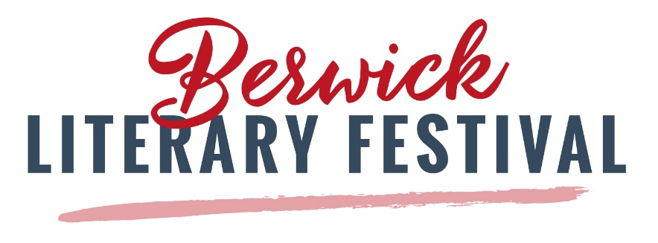
OCTOBER 18, 2020
12:00 - 1:00 pm

Members and friends of the Royal British Legion may be interested in a talk by Harry McCallion, The Undercover War in Northern Ireland – Britain’s Special Forces and their battle against the IRA
Harry served with the Parachute Regiment, underwent selection for 14 Intelligence Company, and completed six years with the SAS, including two tours with their anti-terrorism team. He received two commendations for bravery during service with the Royal Ulster Constabulary. He is thus uniquely placed to tell us this astonishing story.
Harry will be interviewed by Lt Colonel Keith Montgomery, Royal Engineers.
Born in Glasgow, Harry McCallion joined the army after leaving school. In a varied and exciting military career he served with the Parachute Regiment, South Africa’s elite Recce Commandos and 22 SAS. After leaving the army in 1985 he joined the RUC but left in 1990 after a near-fatal car crash. After this he studied law and was called to the Bar. Now a working barrister and writer he has recently received his Master’s degree in international relations. His autobiography Killing Zone was an immediate bestseller.
This event will be online, via Zoom, and free to all. To reserve your place please register at the address below and you will receive your Zoom invitation.
https://berwickliteraryfestival.com/event/harry-mccallion-the-undercover-war-in-northern-ireland-britains-special-forces-and-their-battle-against-the-ira/
Harry’s talk is generously sponsored by Premier Building & Restoration of Berwick-upon-Tweed.
For more information about the Literary Festival and to see the complete 2020 programme, visit our website: https://berwickliteraryfestival.com/

