Furious Pier Incident, Bantry Bay, Ireland 14th May 1921

This year sadly sees the 100th anniversary of a little know incident where three unarmed soldiers were murdered and one badly wounded from “A” Company 2 KOSB. by the IRA in County Cork, Ireland.

Background to the incident:

At the cessation of hostilities in WW1, 2 KOSB were stationed in Belgium in early 1920 they proceeded to the U.K. initially to Dunfermline and then Devonport where the battalion went through a period of re-fit and training.

The 25th June 1920 saw them being warned for duty in Ireland, this was later cancelled however due to the continued internal security problems at the time they were again warned for immediate deployment to Ireland in support of the authorities on the 29th December 1920.

On Monday, the 3rd January 1921 the battalion departed Devonport having had their colours handed over to the garrison church for safe keeping.

The journey began at North End train station, Plymouth at 2230hrs proceeding to Fleetwood in Lancashire where they embarked on the S.S. “Duke of Cornwall” and on the 4th January, arrived at Castletownbere, Bere Island on Friday 5th at 1130hrs.

The battalion at the time was under command of Lt Col EN Broadbent, CB, CMG., DSO. with the following strength of:

Officers = 23, Warrant Officers = 7, Sergeants = 23, Corporals = 25, Boys = 26, Privates = 267 a total of 371. The battalion settled in quickly and was deployed to various outstations.

“A” Company of which the soldiers involved was under command of Maj Lindsay DSO. proceeded on detachment to Furious Pier, Bantry Bay with a strength of:

Officers = 5, Warrant Officers = 1, Sergeants = 4, Corporals = 8, Privates = 44 a total of 62.

2 KOSB Camp on Bere Island 1921

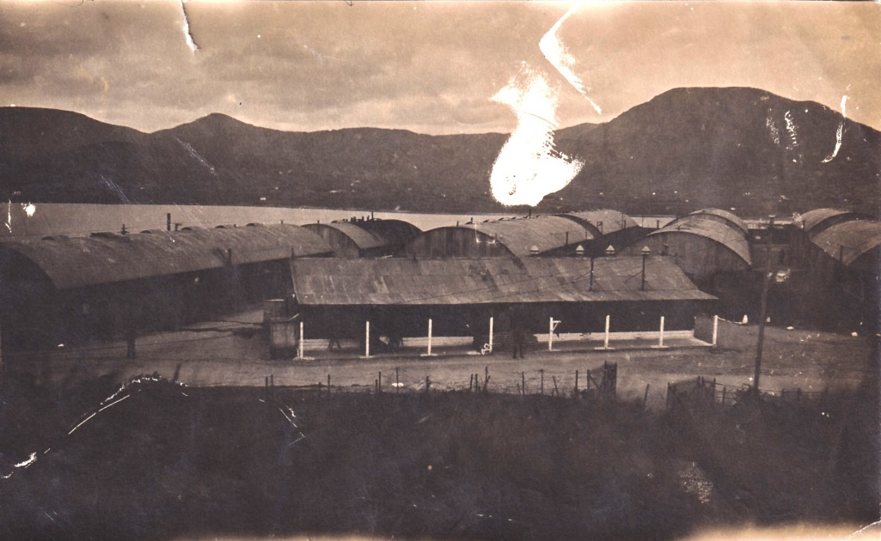

Detachment of 2nd Bn at Berrin Camp 1921 (Capt Moreton K.O.S.B. in the foreground)
(photo from the museum archives)

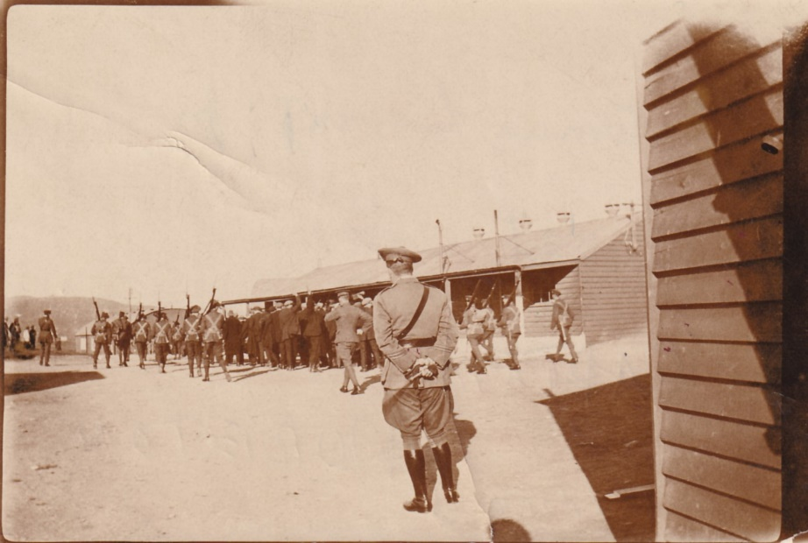

Details of the incident:

Between 1800 – 1900hrs, approximately 2 miles from Castletownbere the ambush of the unarmed Borderers took place. The attack was part of a series of synchronised IRA assaults on British Forces that day at ten different locations throughout West Cork. The Furious Pier murders were reported to have been carried out and reported in the press at that time by Michael Og O'Sullivan a local IRA commander.

Court of enquiry

A military court of enquiry in lieu of an inquest assembled at Berrin Camp, Bere Island on the 16th May 1921 to investigate the deaths of Privates John Alexander Hunter and Robert McMillan, both of Glasgow and Private Donald Chalmers of Lower Sydenham, South East London, all of “A” Company 2 KOSB.

Evidence was given to the effect that after tea on the 14th May three soldiers left camp to go for a walk to Waterfall. On their way, they met three more soldiers from the same battalion and the whole party moved off together. They noticed three girls who encouraged the soldiers to follow them. One of the soldiers thought this strange as the girls in the neighbourhood were usually hostile to the troops. Presently the girls stopped and spoke to an old woman. They appeared to be speaking about the soldiers. The old woman came back in the direction of the camp and as she passed the soldiers she said “Good Night”. Shortly afterwards a Corporal left the party to proceed back to camp by himself.

He had gone about 200 yards when he observed a party of armed civilians coming towards him from the direction of Rosmacowan. As soon as they saw him they formed fours. The Corporal jumped onto a wall and by waving his arms and shouting, endeavoured to warn his comrades. He then made straight for the sea, being chased by five civilians who fired at him. To save himself he took off his tunic and swam out to sea and eventually managed to reach camp. In the meantime, the five remaining soldiers among whom were the deceased men were still following the girls, when one of them lagged behind, he saw the Corporal leap over the wall. He at once warned his comrades, whom replied “Don’t get the wind up” at the same time he saw some civilians coming around the corner and hid in a ditch. By this time the girls had disappeared.

The others then saw the Corporal running and they began themselves to walk across the fields in the direction of the sea. They were suddenly confronted by eight men armed with revolvers who ordered them to put their hands up and doubled them back to the road. The leader who was addressed by the other civilians as “Lieutenant” asked them if they had any arms and they said “No” as the soldiers stood together by the wall the men opened fire on them. Privates Hunter, McMillan and Chalmers were killed and a fourth soldier Private Edwards was wounded and left for dead. The soldier who had hidden in the ditch reported the occurrence to the camp and two lorries with more soldiers proceeded to the scene of the murders.

Medical evidence proved that Private McMillan had bullet wounds in the breast-bone, back and right thigh, Private Hunter had been shot in the spine, left and right thighs, Private Chalmers had bullet wounds in the head, neck, breast, right thigh, right upper arm and left shoulder and finally Private Edwards who survived had a neck wound and left for dead.

In addition, there were two other skirmishes in the local area on this day against armed patrols of Police and British troops with no casualties reported. As a subsequent reaction to the murders an order was issued that all the shops in Castletownbere area had to close their doors for two days (17 and 18 May) out of respect for the three dead soldiers.

On 23, 24, and 25 May 1921 the military authorities destroyed the houses of five named persons and their families by way of reprisal: William Dwyer (Ballycrovane, Eyeries); Frank Sullivan (Inchintaglin); Jeremiah Connor (Ardgroom); T.P.S. Spillane (Waterfall); and Timothy Murphy (Rossmackowen). These houses were destroyed ‘on the grounds that their owners were supporters of armed rebels, and that such armed rebels carried out cowardly and murderous attacks on the forces of the crown, who were unarmed, in the district of Furious Pier.

Service details of the Borderers killed and wounded:

3180263 Private John Alexander Hunter

John was born in Enzie, Banff, Banffshire and attested for the regular Army on the 8th November 1920 aged 19 years and 9 months, his place of attestation was listed as Glasgow, his trade on enlistment was Apprentice Fitter.  His next of kin was his Aunt, Mrs Wiseman, 51 Beechgrove Street, Bridgeton, Glasgow. and is buried in a shared grave in the Necropolis Cemetery, Glasgow | 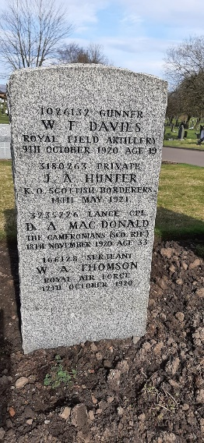

3180640 Private Robert McMillan

Robert was born in Rutherglen, Glasgow, Lanarkshire, and attested for the regular Army on the 23rd January 1921 aged 18 years and 6 months, his place of attestation was listed as Glasgow, his trade on enlistment was Labourer. The enlistment book also lists him as having initially joined the Royal Scots Fusiliers with a service number of 44223 and then transferring not long after to the KOSB.  His next of kin was his Father, Robert McMillan, 5 Baronflat Street, Rutherglen, Glasgow. and is buried in Rutherglen Cemetery, Glasgow. | 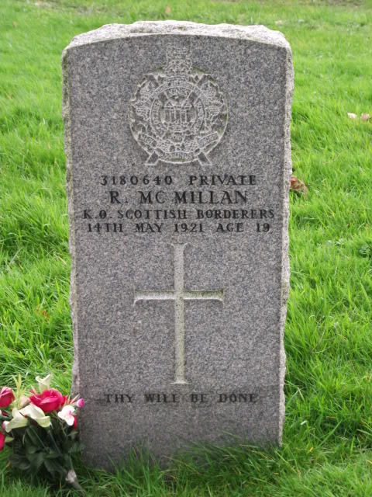

3180441 Private Donald Chalmers

Donald was born in Deptford, London, Surrey and attested for the regular Army on the 2nd December 1920 aged 20 years and 278 days, his place of attestation was listed as Whitehall, London, his trade on enlistment was Steward. The enlistment book entry also lists Donald as having initially joined the Rifle Brigade with a service number of 1083 and later transferring to the KOSB.

Donald’s next of kin was his Mother, Mrs A. Chalmers, 45 Staunton Street, Deptford, London. And is commemorated in Ladywell Cemetery, South London.

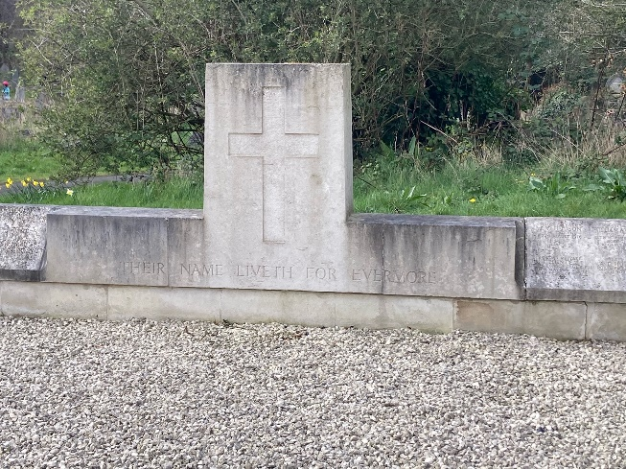 | 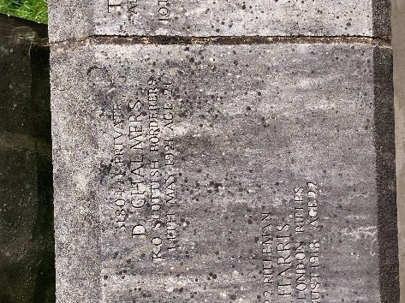

3180144 Private Arthur Edwards

Arthur was the only survivor of the four Borderers taken prisoner. He was born in Stafford, Staffordshire and attested at Glasgow for the Regular Army on the 30th September 1920. His trade on enlistment was Labourer.

His next of kin was his father, Mr Charles Edwards, 16 Bellfield Street, Glasgow. Due to his wound, he was later discharged on the 11th August 1922 with his conduct given as “Very Good”.

Entry in the Battalion diary dated 15th may 1921:

Heading: Brutally murdered by rebels at Rosmacowan, Co Cork.

The above men were proceeding to Waterfall Post Office for stamps. This dastardly and cowardly act, perpetrated by a band of 30 rebels is not an act of war but a murder pure and simple. During this trying period, the morale and conduct of the troops was excellent.

Strong words from the commanding officer who would have had to manage the anger and rage felt at the time by his officers and men.

It was later reported in the Cork Recorder that £400 in compensation was awarded to the mother of Private Chalmers; the victim was said to have been ‘chased, captured, and shot’ while going with his comrades to the post office. The compensation would have been a small price to pay for the loss of a son.

Private Edwards who was seriously wounded at the same time was awarded £600.  Arthur Edwards later gave an account of the incident to “The Berwickshire News” dated June 7th 1921.  Extensive research in the regimental archives has sadly not thrown further light on the identification of the Junior Non-Commissioned Officer (JNCO) and Private who managed to escape.  It is also worth noting that, although the personal and newspaper accounts differ slightly in numbers of the rebels, there is no taking away the fact that the three young Borderers were sadly murdered in a troubled period in Ireland’s history and one that sadly had comparisons with the three soldiers from the Royal Highland Fusiliers who were also sadly murdered in March 1971, 50 years later.  Today these young Borderers will be remembered with Association members laying wreaths at their final resting places. | 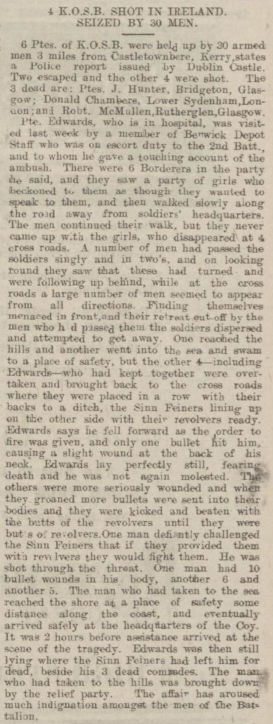

In 1898 the British Military raised a compulsory purchase order on the eastern end of Bere island mainly for its deep-water port and approaches to the Atlantic Ocean.
Statements issued after the incident and recorded in the Irish Times dated 13th June 1921
The Regimental diary states that the soldiers were on their way to the post office in Waterfall to buy stamps.

