Lieutenant Gustavus H B Coulson VC – 18th May 1901
On this day, 120 years ago, Lieutenant Gustavus Hamilton Blenkinsopp Coulson of The King’s Own Scottish Borderers, whilst serving as the Adjutant of the 7th Mounted Infantry Regiment in the South African War, carried out a number of acts of bravery, culminating in his own self-sacrifice to save the life of one of his soldiers, which resulted in the award of the British Army’s highest honour for gallantry, the Victoria Cross.
Lt Coulson was born on 1st April 1879 into a distinguished military family that hailed from Castle Blenkinsopp, some 40 miles West of Newcastle. Commissioned into the 4th Battalion (Princess of Wales’s Own) Yorkshire Regiment, he transferred to the K.O.S.B. in July 1899, aged 21, in time to join the 1st Battalion on active service in the Second Boer War. During the conventional phase of the War, Coulson distinguished himself as an exceptional officer by being mentioned in despatches twice, once by Lord Roberts and once by Lord Kitchener, as well being awarded the Distinguished Service Order.
After their initial defeat, the Boers adapted themselves to guerrilla warfare, forming gangs called “Kommandos”, using their mobility as highly skilled riders, their marksmanship and their superior local knowledge of the “veldt” countryside to cause havoc to the British Lines of Communication. To deal with this threat and to supplement the too few cavalry regiments available, each Infantry Brigade was ordered to form an adhoc Mounted Infantry (M.I.) Regiment; the 1st K.O.S.B., along with the 2nd Northants, the 2nd Hampshires and the 2nd Lincolns established the 7th M.I. Regiment.
On the 18th May, Lt Coulson was part of a rear guard of the 7th M.I. Regiment that was attacked near Lambrechtfontein. Seeing that the maxim machine gun was about to fall into enemy hands, he gathered some soldiers together and led them in a counterattack to save the gun. On his way to re-join the column, he noticed Corporal Cranmer, his servant, had been wounded and unseated from his horse, which had been killed. Coulson rode back to pick up Cranmer onto his horse, but they both fell to the ground, when his horse was shot from under him. Managing to get his wounded horse back up again, Coulson gave it to Cranmer, telling him to save himself, as he insisted he could cope on his own. Cpl Cranmer was able to make his way back to the column to receive medical assistance and survived. Noticing that the Adjutant was now in a similar plight, Corporal J Shaw (4792) of the Lincolns rode back to save Coulson, but as they were returning, a Boer bullet passed through Coulson and lodged itself in Shaw. Coulson fell off and later died of his wounds, but Shaw, unable to save Coulson, staggered on, his own horse having been wounded badly, before falling off also. Shaw was rescued by Corporals Fraser (KOSB) and Claxton (Lincolns) who brought him back to the safety of the rear guard and he survived.
Corporal Shaw was awarded the Distinguished Conduct Medal and promoted to Sergeant in the field for his gallantry in attempting to save his officer’s life. His brother, Ernest, (4292) also a Corporal in the Lincolns was wounded in the same action. In recommending Lt Coulson for the Victoria Cross, his Commanding Officer wrote that Coulson had “on many occasions throughout the Campaign displayed great coolness and gallantry under fire." The family erected a memorial to him in St Peter's Church, Tiverton, Devon.
In 2003, Mr Stephen Verralls, the grandson of Cpl Shaw, unveiled a new headstone to the grave of Lt Coulson V.C. in Lambrechtfontein, accompanied by a guard of honour from the Witwatersrand Rifles Regiment, a South African Army Reserve unit formed in 1903 from troops that had fought on the British side of the conflict and was affiliated to the K.O.S.B in 1995.
Lt Coulson’s was the first of six Victoria Crosses awarded to the K.O.S.B.
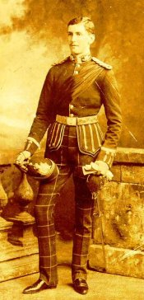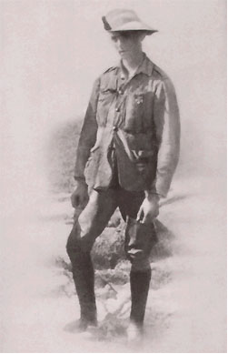
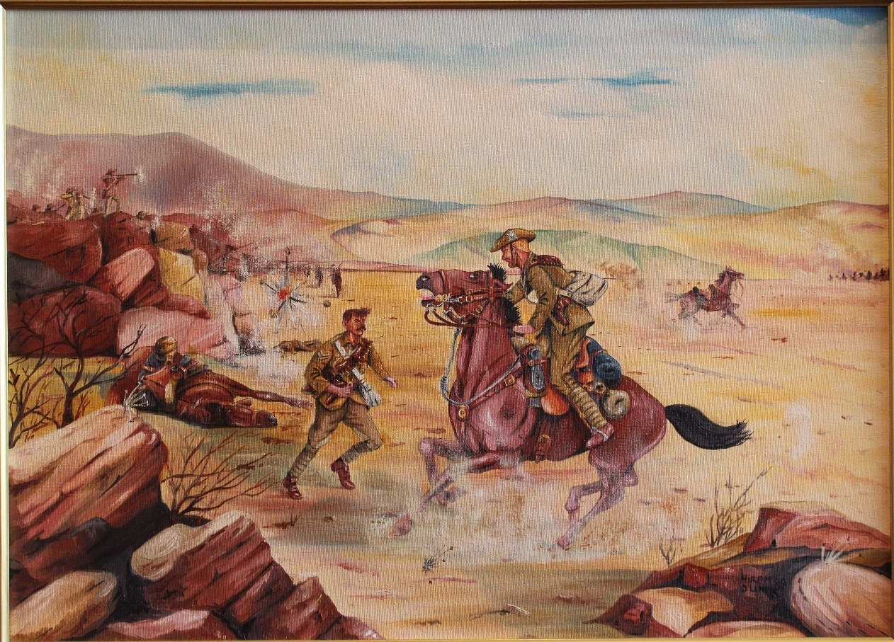
Lieutenant and Adjutant GHB Coulson VC, DSO, KOSB (7th Mounted Infantry) by Hiram Dunn

