 | Lieutenant Colonel Jonathan Tink  Regimental Secretary  Regimental Headquarters  The Royal Regiment of Scotland  The Castle  EDINBURGH  EH1 2YT  Email: Jonathan.Tink100@mod.gov.uk> | 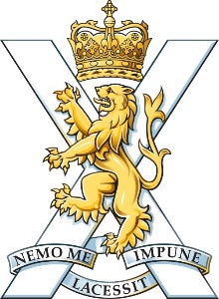

Secretary  KOSB Association | 26th July 2021

Dear Spike,

I write to update you on the Royal Regiment of Scotland following the Integrated Review (IR) and our ongoing strategy review.

The Chief of the General Staff recently briefed on the Integrated Review (IR) and the considerable change to the Army as it transforms to meet the challenges of the future. The Colonel of the Regiment is very confident that The Royal Regiment of Scotland will continue to offer exciting and fulfilling opportunities.

The establishment of the Ranger Regiment will see 1 SCOTS take their place in this new Tier 2 force. This is a positive step for the Battalion, offering a new and demanding role. This coupled with the operational drumbeat of our other Battalions means the Regiment will continue to offer our people the challenges that we thrive on. In the Autumn the Army will issue orders detailing the future roles, structures, operational commitments and basing for our Regiment; change is inevitable.

The Regimental Council has conducted a thorough strategy review based on the IR and surveys offered to all in the Regimental family. Our revised strategy will be focussed firmly on the future whilst protecting our links to our proud heritage. It will ensure we can react to the orders for change; uphold the high standard to which our Regiment performs; and ensure we maintain our position at the forefront of the UK Defence.

The strategy will be published in the autumn and I will ensure you receive a copy. In the interim I and my SO2 Veterans, Lt Col (Retd) Kevin Wood, will be in touch to plan a visit to meet and brief you in more detail on the work we are doing to support our veterans.

Yours sincerely,

Jonathan

