Embargoed until 00:01 9 August 2021

CULTURAL ORGANISATIONS LAUNCH CONSULTATION ON POSITIVE NEW VISION FOR BERWICK BARRACKS

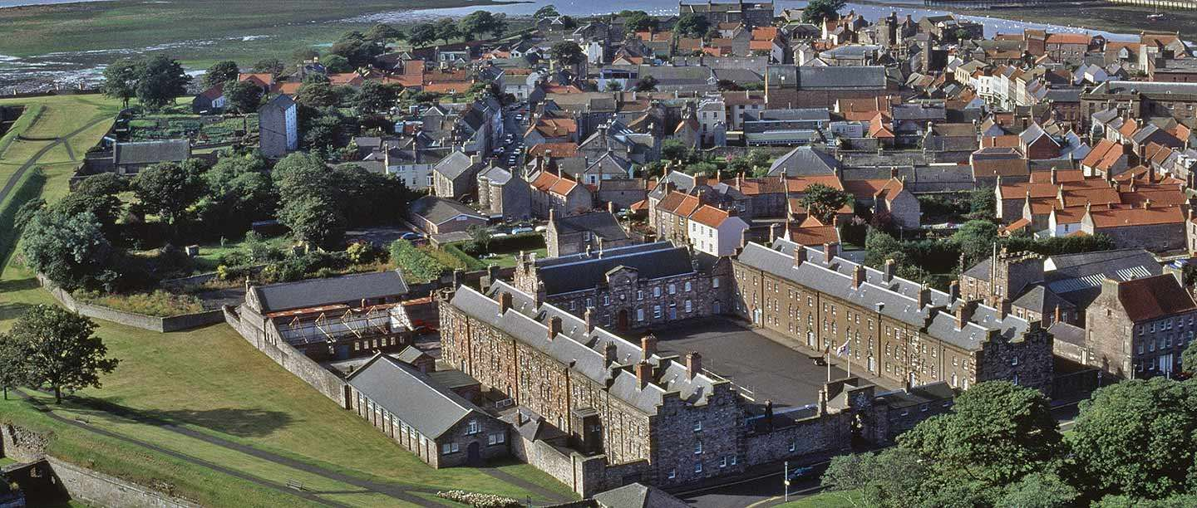

Heritage and cultural organisations in Berwick-upon-Tweed have teamed up to launch a consultation on a positive new vision for the future of the town’s 18th century barrack buildings this week. The Group are seeking the views of the wider community on how the property can continue to play a central role at the heart of community life in the town. On Saturday, 14 August local residents will be able to visit the barracks to see the proposals and discuss these with the partners of Berwick Barracks.

The vision sees the members of the Berwick Barracks Partnership working together to develop the buildings as a thriving cultural hub for the town, bringing empty buildings and spaces back into use in a way which supports tourism and the local economy. Over the last five years, English Heritage Trust, the Kings Own Scottish Borderers Trustees, the Maltings (Berwick) Trust, Northumberland County Council, Museums Northumberland and the Berwick Barracks Heritage Trust have been working together to develop the new vision for the future of the site.

As part of the plans, exhibition, gallery and cultural space on the site would be updated and improved, Northumberland County Council would work to relocate the Berwick Archives to the site - including new research rooms – and studio spaces would be developed for local artists.

Improvements would also be made to the Parade Ground to allow it to continue to play an active role in the life of the town, both through existing events such as the Minden Day Parade and local festivals and also through a wider public programme of events. A café or restaurant would be developed within the Officers Mess and a shop within the Gatehouse, and the West Block and Clock Block would be returned to residential use.

The barracks at Berwick-upon-Tweed - also known as Ravensdowne Barracks – were constructed by the British government between 1717 and 1721, following the fighting there during the Jacobite rising of 1715. They are the largest and finest barracks built in England in the early 18th century.

Andrea Selley, Territory Director for the North at English Heritage said: “For several years, we have been working together with local partners to develop this exciting future for the barracks, and I am delighted that we are now in a position to share it with the people of Berwick. We believe this vision shows how the barracks can have a positive future as a place for both local residents and visitors to the town to enjoy, and we hope local people will want to work with us to develop that vision to the next stage together.

Northumberland County Councillor Jeff Watson, cabinet member with responsibility for healthy lives said: “This proposal aims to breathe new life into the barracks which play a key role in the history of the town, and we look forward to working with English Heritage on it. This is a great opportunity for local people to have their say, and I would encourage residents to come forward with their views.”
Michael Orde, Chair of Museums Northumberland said: “Museums Northumberland have worked with the Berwick Barracks partners as the proposals have taken shape, and we will continue to do all that we can to support the successful delivery of the vision for the site.”

Sir Philip Mawer, Chair of the Berwick Barracks Heritage Trust said: “I am delighted for Berwick that sustained work by all partners has enabled publication of this vision of a sustainable future for the Barracks in this, their 300th anniversary year. I urge all who want to see that vision developed to completion to give their feedback, so that together we can grasp this major opportunity for the town and all who live and visit here.”

Angus Loudon, Chair of the King’s Own Scottish Borderers Association said: ‘The King’s Own Scottish Borderers Association are delighted to be partners in this exciting vision for The Barracks, which was home to our Regimental Depot for over 80 years, and which has been our Regimental and Association HQ for almost 140 years. Our very close relationship with The Barracks and the town and its people can only be strengthened through this development.’

Susan Hallsworth, Chair, Maltings (Berwick) Trust said: We are delighted that the refurbishment of the Gymnasium Gallery, as part of our Borderlands development, will be the first stage in realising our partnership’s collective ambitions for the site. We very much welcome this opportunity to share our Big Picture with the people of Berwick, and to play an active role in the Barrack’s exciting future.

The Berwick Barracks Partners will be leading tours of the site for local residents and stakeholders to discuss the proposals at 10am, 11am and 12 noon on Saturday 14th August.

Proposed plans can be viewed online at https://www.english-heritage.org.uk/visit/places/berwick-upon-tweed-barracks-and-main-guard/new-vision-for-berwick-barracks/

The dedicated email address for feedback is TheLivingBarracks@english-heritage.org.uk

ENDS

For more information, please contact:
Tom Jones – PR Manager at English Heritage
Thomas.jones@english-heritage.org.uk
07795 314 066

Notes to Editors

English Heritage cares for over 400 historic buildings, monuments and sites - from world-famous prehistoric sites to grand medieval castles, from Roman forts on the edge of the empire to a Cold War bunker. Through these, we bring the story of England to life for over 10 million people each year. Registered charity no. 1140351. www.english-heritage.org.uk

