OP COMMANDO- KOREA 1-4 OCT 1951
On this day 70 years ago the men of 1 KOSB as part of the 28th COMMONWEALTH BRIGADE would move by MT to the right flank of the Divisional area then North along the east bank of the river IMJIN. The aim of COMMANDO was to prevent the Chinese from launching an autumn offensive and to bring them to the negotiation table.
A detailed plan was unveiled to the Jocks of the BN which is detailed below in the words of Cpl Geordie Laidlaw 2 Sect 3 Pl A Coy, from his memoirs.
“Then the nitty gritty, the Borderers had six ridges/hills to take. One on the evening of the 2nd in advance of the others and four on the 3rd leaving the “big yin” for the 4th- nae problem so far. It was planned that A Coy would sneek onto the first one CAT .238, the first to be off, then using CAT as a jump off the other three Rifle Coys would go for the rest, leaving the DOME again for A Coy. On the morning of the 3rd following a horrendous artillery programme to liven things up, C Coy would go for LONG and simultaneously B Coy for FINGER RIDGE more or less adjacent. When these two were secured then KIDNEY would be taken (by whom planned we’d never know) and A Coy would bash on through for the DOME which lay at the Northern base of the “big yin” KOWANSAN .355. Then on the 4th D Coy would press on and take the “big yin” .355.
That was basically the order of attack on the 2nd, 3rd, and 4th days of Oct 1951, and the one briefed for.
But the Commanding Officer had other schemes of assault in his cranium just in case. (As things turned out that was only too well)”.

The move by MT would be staggered, slow and deliberate initially heading in the wrong direction to confuse the Chinese then crossing the IMJIN at GLOSTERS crossing. The vehs would slow to walking pace and spaces would increase. The Jocks would see a poignant sign which read “DUST BRINGS SHELLS-YOU ARE UNDER ENEMY FIRE FROM THIS POINT” and all around the wreckage of war from previous battles. By now the men of A Coy in the leading vehs were six miles inside NORTH KOREA and so as not to provide the enemy with an easy target the debussing would happen on the move. Packs would be thrown out first, Jocks would jump off and hide at the side of the track in whatever cover they could find. The Pl Sgts would corral their men, battle discipline was essential. Within 20 minutes the men of A Coy were complete on the ground as the first troops of the 28th Commonwealth Bde on Chinese real estate. The vehs would the return to collect the rest of the Borderers. After some rest the Jocks moved off in silence to the river crossing, collecting life jackets getting onto boats and ferrying across the IMJIN river. All drills were slick in the early darkness, so efficient were the jocks and boat crews that nobody got wet feet and the Chinese never detected them.
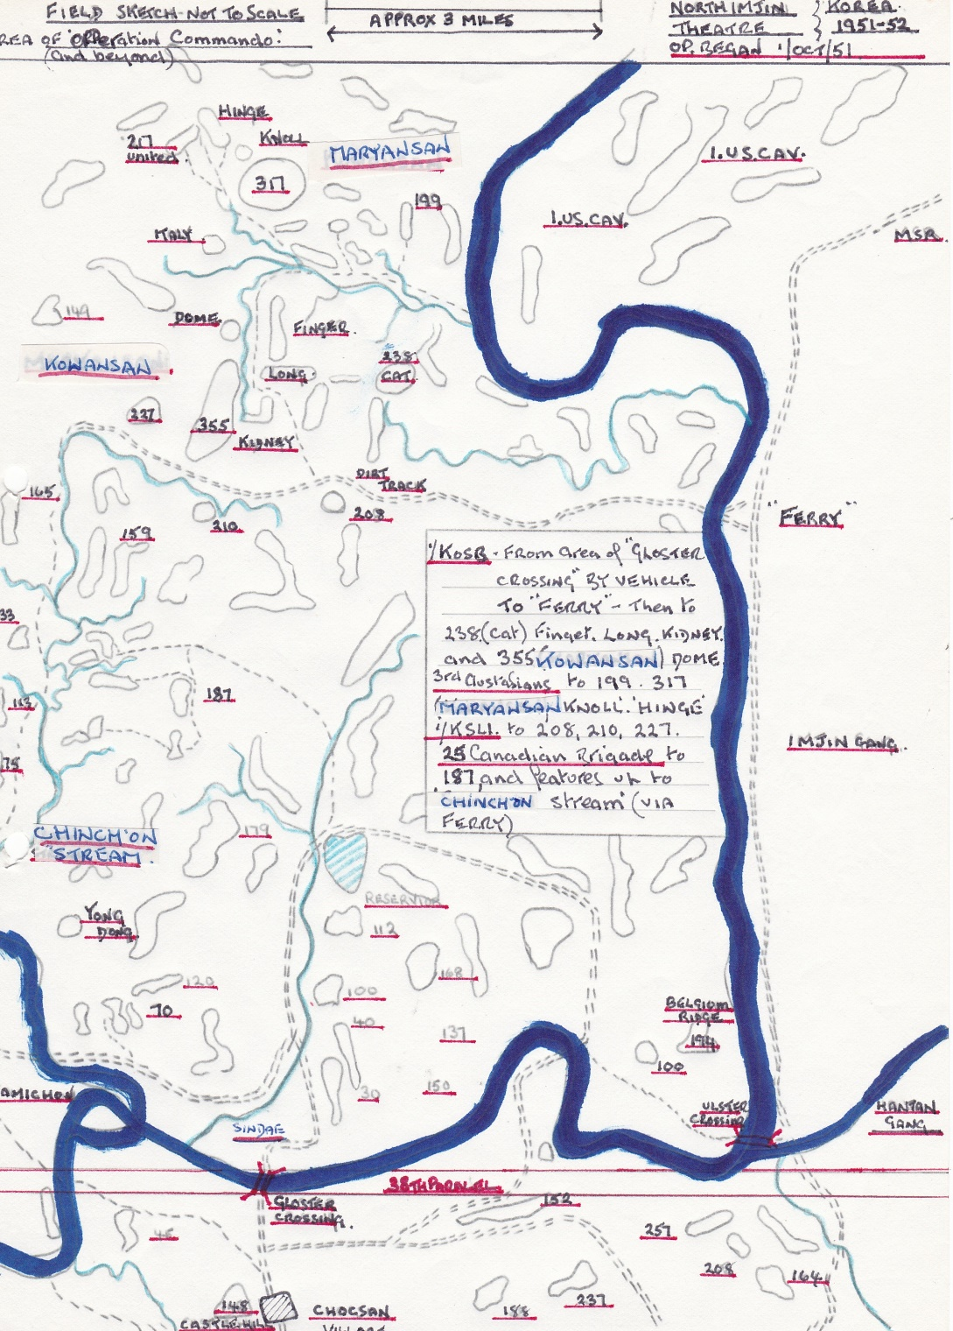

The Jocks of A Coy moved silently and briskly away from the crossing to a wood a mile away, where they would spend the dark hours in anticipation of the battle ahead. A moment of light relief for 3 Pl as told by Geordie Laidlaw.

“Then a belly laugh all around at a comment from Pte John Maleny who declared that Lcpl Michael Fitts had proved to be no sailor, having spewed his hoop up during the crossing. Sojer humour, typical, taking the piss behind the safety of darkness, but this time even the bold Mickey joined in. Our humour short lived was cut off by a distant voice telling us “tae shut oor gubs” no doubt the Sergeant Major, his request obeyed the only sound s were cans being opened for scoff and urine splashes on the vegetation”.

The advance continued, darkness cleared the air warmed, limbs ached, stop start, packs on packs off, keep the man in front in view and always waiting for the enemy to fire. As they lead the men of 3 Pl see a lone sentry in the bush, a Canadian they have reached the Start Line, later that afternoon they would advance on CAT.

All around the 28 Bde was moving into position for the assault, the Generals plan was for a silent approach in then unleash hell on the morning of the 3rd. The jocks of 3 Pl pressed on with the looming feature of.355 looking down on them sometimes covered in mist, a sense of foreboding ran through every Borderer, have we been seen, why haven’t they attacked us. As daylight begins to fade the Pl make their move on CAT while the remainder of A Coy are ready to give covering fire. As they move up the slope there is evidence of the previous night’s engagement by the Canadians dead Chinese and dug fighting positions which are quickly occupied by the Jocks, still no contact. Within minutes 3 Pl have secured their piece of CAT, quickly the rest of A Coy join them and begin to secure CAT. Suddenly just as the last light was fading a single shell screams over and impacts in the gap recently vacated by the Company. On edge the jocks wait for more, none arrive, digging continues at a pace with every man eager to get below ground for the night.

As A Coy consolidated their position they were able to go onto 50% at stand to-the remainder being able to rest a wee bit. Although as Geordie Laidlaw recalls “No puffs on a fag though, Chinky too close”.

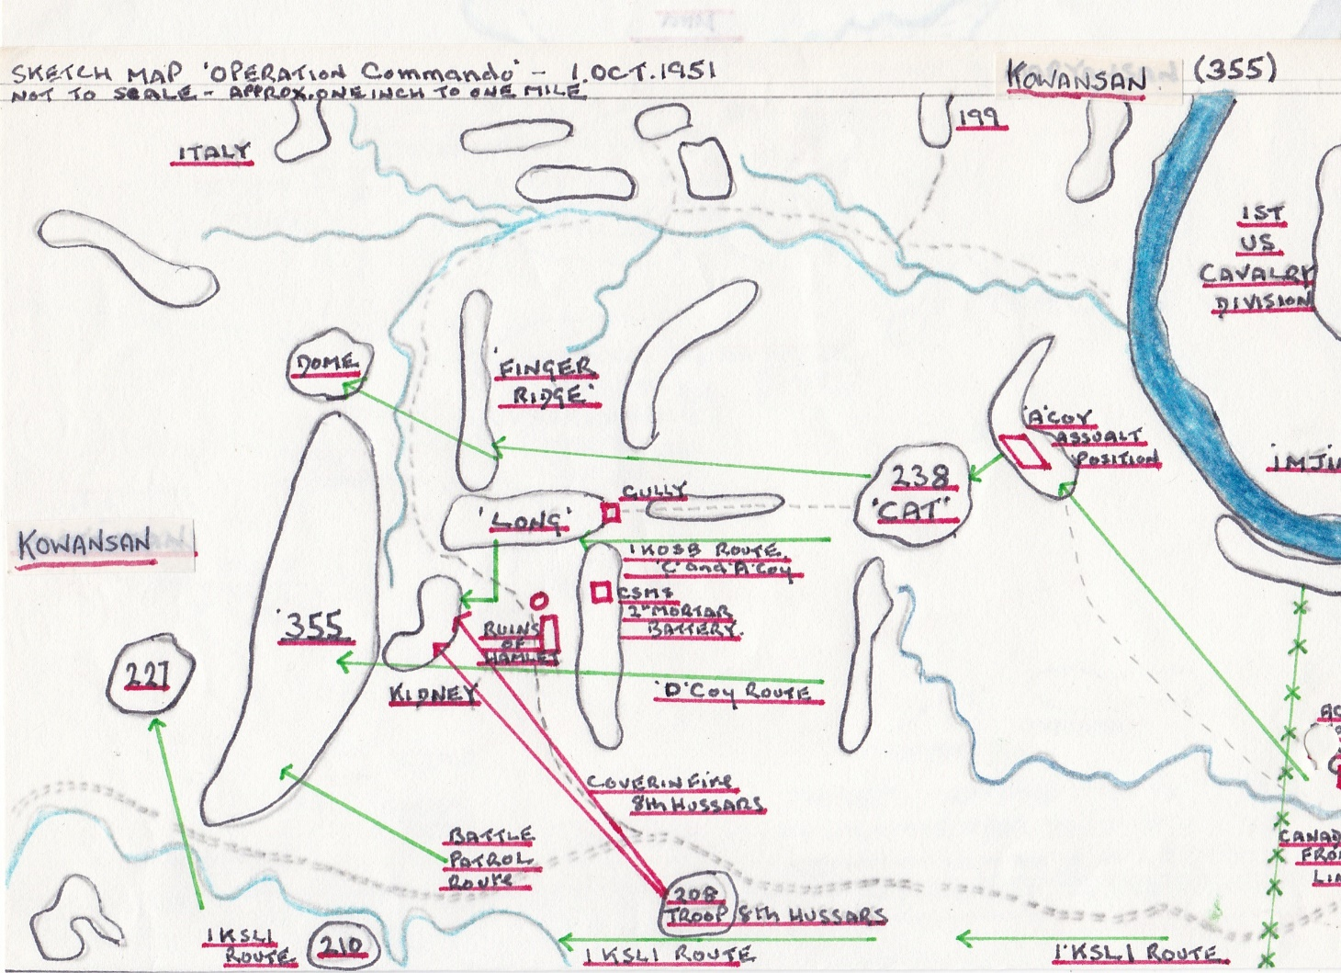

The Company position on CAT would now become very busy as many specialists, staff Officers, MMG teams, FOOs and Commanders came in for the impending assault. By 0500 on the 3rd there were over 200 Commonwealth troops on CAT all exercising the highest standards of battle discipline. To the north the Australians’ were in position to the south the KSLI were waiting to attack.

The COs TAC party move in behind 2 Sect making them the second closest Borderers to the Chinese, MMGs are ready. At 0715 the sky erupts as guns open fire, the Vickers MMGs on CAT would fire with no tracer and with blankets in front of their positions so as not to let the enemy see them. The artillery would fire smoke to reduce Chinese observation, the noise is deafening. Just before full dawn movement begins after an hour of bombardment the Jocks of B&C Coys move forward into the assault. The going is tough, thick vegetation steep ravines make movement and control difficult and slow. By 0845 C Coy have fought their way onto the lower slopes of LONG and are engaged in heavy hand to hand fighting. The enemy are determined and by 1200 the lead elements of C Coy have a footing on LONG but are unable to dislodge the enemy from the whole feature, they are coming under intense fire from enemy on KIDNEY. Seeing the stalling of C Coy the CO orders the OC Maj Little to reorg his troops and withdraw his forward elements from LONG, he also orders A Coy under Maj Duncan to move forward to assist C Coy. Meanwhile B Coy under Maj Harrison had captured FINGER despite heavy enemy Arty and Mor fire. They are ordered now to provide f/sp for the assault on LONG.

At 1415 A&C Coys launch their assault on LONG after fierce fighting the objective is secure by 1530. Immediately A Coy are ordered to advance and capture KIDNEY, this is done quickly despite fierce enemy resistance and hand to hand fighting. Throughout these attacks the Battalion Battle Patrol had been providing support on the left flank along with a Squadron of 8th Hussars.

Now as the light fades the Borderers are ordered to consolidate on KIDNEY, LONG and FINGER, evacuate wounded and resupply forward companies. A task made difficult due to the terrain and proximity of the enemy.

Early on the 4th D Coy under Maj Robertson-McLeod and the Bn Battle Patrol successfully scale and fight the enemy off of Pt. 355.

During 36 hours of fighting on the 3rd and 4th of October the Bn would suffer 7 KIA and 34 WIA, which was mercifully far lower than expected, the Borderers fought with courage under inspired leadership. The Chinese would return.

