THE GUY FAWKES BATTLE KOREA 4-5 NOVEMBER 1951
During the night of the 3rd and morning of the 4th of November the men of 1 KOSB occupied a defensive position around .317 and .217. The Bn frontage was some 3,000 yards and was not ideal. The three forward Companies B on UNITED, C on HINGE, C& D on KNOLL and D on PEAK with A Coy in depth had great difficulty in preparing any defences, as they were overlooked by the enemy who would bring down heavy IDF on any movement or noise. This also hampered any movement of combat supplies. The enemy was particularly close on HINGE being some 300 yards away making patrolling very restricted. The Bn was now Commanded by Maj Tadman as Lt Col MacDonald had taken over Command of the 28th Bde on 25th Oct.
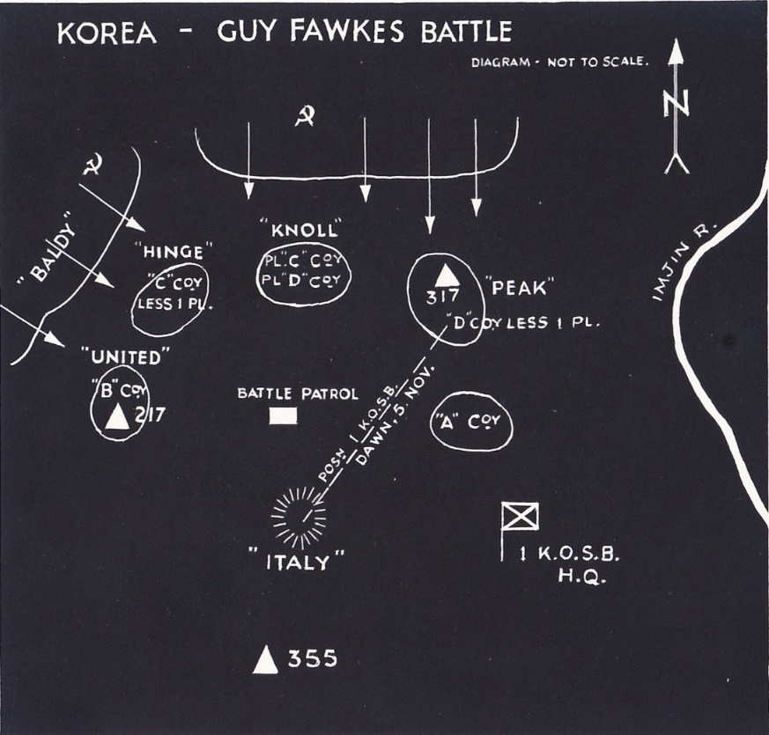
During this period there were signs of increased enemy activity on the Bns front accompanied by intense IDF. Despite counter battery fire and airstrikes the enemy guns remained very effective and almost impossible to locate due to being sited in tunnels which had been dug in the previous months.
There were 2 Platoons on the KNOLL, 7 PL commanded by a Kelso man 2Lt Willy Purvis and 11 PL commanded by 2Lt Barney Henderson. A recce patrol commanded by 2Lt Purvis discovered a “comfort girl” the property of a senior Chinese commander in a hamlet, all through the patrol he felt they were being watched. Recce patrols by the Bn Battle Patrol revealed recently dug crawl trenches, they also heard tracked vehicles undoubtedly self-propelled guns.
By first light on the 4th the Borderers saw a large white sign on the opposite feature BALDY which stated “go home Britishers or this hill will be your graveyard”, there was a stretch of trench dug from BALDY for 200yds towards HINGE. Around 1000hrs enemy were seen moving along the trench, then it was reported that many hundreds of enemy were assembling behind BALDY. Aircraft were called in to attack, the Borderers cheered as the Chinese were strafed with, Cannon fire, Napalm and rockets. Despite the intense defensive fire the Chinese still managed to intensively shell the Borderers positions with Mortar and Artillery fire.
By 1600hrs on the 4th as the sun set in the eyes of the Borderers having been under fire all day the enemy shelling intensified to a rate of 6000 rounds per hour. The ridgeline defended by the three forward companies was now an inferno of smoke, dust flame and explosions. All available assets were called in to provide defensive fire including air and artillery, it was now evident the Borderers were about to be attacked.
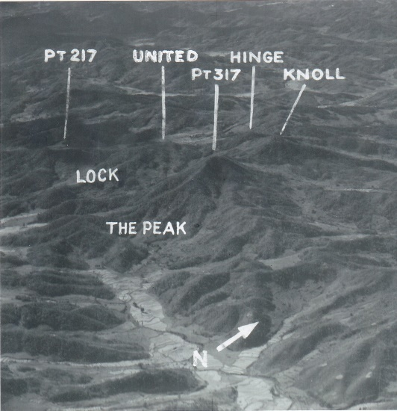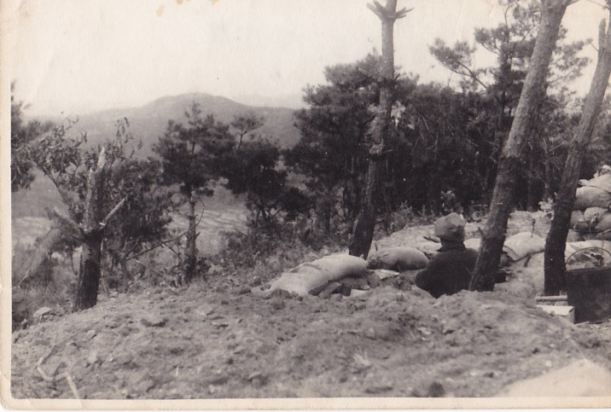
Air photo of Bn positions Left edge of C Coy before the battle
Around 1615hrs the forward Borderers reported seeing wave upon wave of enemy advancing on their positions. As quick as the Borderers shot them they were replaced, picking up weapons of the fallen and advancing as if dazed and doped, surging forward the enemy were hit by their own and Borderers fire. It was now apparent that this attack was a determined effort by the Chinese to regain the Kowang-San region. Intelligence sources would later report that the Borderers were being attacked by a Division of 6000 men.
All along the front the Borderers were fighting for dear life expending ammunition at a rate not even seen in WW2, resupply was vital, the Company Sergeant Majors would earn their pay this night. The enemy surged over the broken wire using pole charges and straw matting, communications were difficult as all land line was cut and most of the radios destroyed by shrapnel. As darkness lengthened the Pl 2” mortars kept up a steady stream of parachute flares to illuminate the enemy for the jocks too shoot them.
HINGE was first to fall and after bitter close combat and overwhelming enemy C Coy were ordered to withdraw towards A Company. By 2200hrs D Coy on PEAK had been forced to withdraw towards A Coy. On KNOLL the enemy appeared from bunkers and trenches “dug right under our noses the night before”, the 2 Platoons here went totally silent after vicious hand to hand fighting, the worst was feared. On the left B Coy were undertrack on UNITED, the Chinese had used Self Propelled guns and rocket launchers to destroy every observation post and machine gun position simultaneously before their Infantry attacked. The forward Pl was overrun and crawled back to the Bn Battle Patrol, the remainder of the Company fell back to prepared positions on the reverse slope which had been dug on the orders of the OC Maj Harrison. From here B Company would continue to fight using flares to illuminate the enemy so they were silhouetted as they came over the crest, parties of Borderers with Bren guns and grenades would engage the enemy at close quarters causing them to pay a very high price. As the enemy kept pouring in men to the slaughter it became apparent that B Coy would have to withdraw, the OC had ordered his Company runner Pte Bill Speakman to cover part of the crest. He stuck to his task inspiring his comrades to fight off successive enemy assaults. His actions would allow the Company to successfully withdraw from UNITED, for this he would be awarded the Victoria Cross for Valour. They would move to a new position ITALY with the Bn Battle Patrol. On PEAK D Coy still held a part, A Coy were now the forward Company with the remains of C Coy now the Bn reserve around Bn HQ. It is recorded that during a 4 hour period the 3” Mortar Platoon fired 5,000 rounds.
Sometime after midnight a radio message from D Coy reported that the 2 Platoons on KNOLL were still holding out, they were ordered to withdraw but there was no further word from them. In the small hours enemy shelling switched onto A Coy with intense tracer fire being sent down the valleys between PEAK and ITALY. The Borderers though depleted and short of ammunition and weapons braced for another onslaught. It never came the Chinese appeared to have had enough their losses were over 1,000 KIA.
At dawn a dishevelled and blood stained figure appeared at BHQ to be greeted by an astonished CO: “where the hell have you come from”.
It was 2Lt Willy Purves reporting his Platoon present and correct. After the initial attacks the Platoons still held their positions, Lt Barney Henderson had been wounded so Purves took command of both and organised the defence of KNOLL and held it as the other positions fell. He had ignored the initial order to withdraw as he believed he could hold on however on hearing a second order from D Coy he decided to move as his men were down to their last rounds. He ensured all casualties and equipment were collected and even though wounded he led his men down off the KNOLL back to BHQ. Amonst the many awards for valour that night this young Officer would be awarded the Distinguished Service Order for leadership and bravery, the only National Service Officer to do so, he was 19.
The Guy Fawkes battle as the Borderers named it would exact a heavy toll on the enemy, for the Borderers there would be an immediate casualty check of 7 KIA, 87 WIA and 44 MIA. Later the KIA would rise to 27 men.

