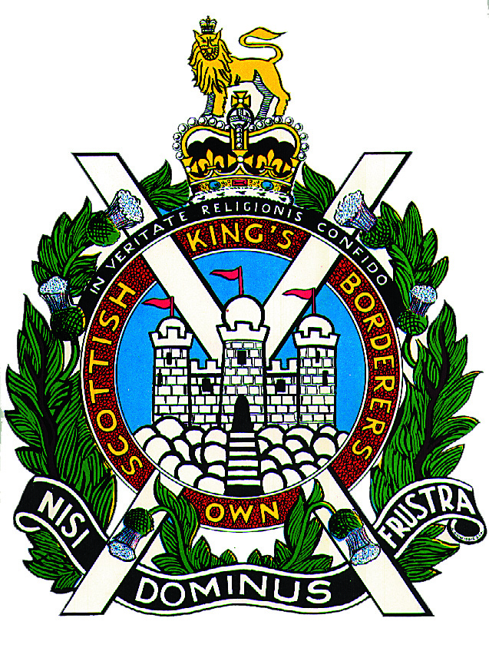

The King’s Own Scottish Borderers Association
Berwick Branch
Branch Secretary: Mr W Heaney
Tel: 01573 223316

January 2022
BERWICK BRANCH ANNUAL DINNER 2022.

The Berwick Branch Annual ‘Raising of the Regiment’ Dinner will be held on Friday 18th March 2022 at the Marshall Meadows Manor House Hotel, Berwick upon Tweed, at 7.30 for 8pm.

This Dinner is open to all members of The King’s Own Scottish Borderers Association, their wives, families and friends. It is also open to Non-Members of the Berwick Branch. The cost will be £25.00 per person, which also includes great entertainment during the evening. Bring your friends along with you to enjoy a delicious three-course meal and a great night out.

I would be most grateful if you could return the attached acceptance form, completed and signed, to me by no later than Friday 04 March 2022.

Accommodation is available at the Hotel and this can be booked by calling the following number:

Marshall Meadows Country House Hotel: 01289 331133 (mention KOSB Dinner for reference)

Double Room: £90.00 (incl Breakfast)
Single Room: £65.00 (incl Breakfast)

Additional accommodation is also available as follows:

Travelodge, North Road, Berwick upon Tweed TD15 1UQ Tel: 0871 984 6279.

Premier Inn, Sandgate, Berwick upon Tweed TD15 1ER Tel: 01289 543210 or
Tel: 0871 527 9676

Single, Twin & Double Room Flexi Rate: £49.00. Non-Flexi Rate: £39.50.

There are a large number of Hotel and Bed and Breakfast in Berwick that most of you will be familiar with and will use in the summer so please contact them if you prefer.

Please get round your friends and encourage them to join you for an excellent three-course meal and great entertainment.

I look forward to seeing you on Friday 18th March.

W Heaney

W Heaney
Branch Secretary

BERWICK BRANCH ANNUAL DINNER ACCEPTANCE FORM.

Please reply to: W Heaney, 53 Berrymoss Court, Kelso, Scottish Borders TD5 7NP

Tel: 01573 223316 or 07747 483544
E-mail: bhxxv@btinternet.com

Please submit your return by Friday 04 March 2022. Please use Block Capitals.

From: …………………………………………………………………………….

Address: ……………………………………………………………………………..

……………………………………………………………………………..

……………………………………………………………………………..

E-mail: ……………………………………………………………………………..

Berwick Branch Annual Dinner Friday 18th March 2022.

1 WILL/WILL NOT BE ATTENDING.

I enclose a cheque for the sum of £…………. covering ………. persons at £25.00 per person for the following people in my party:

………………………………. ……………………………… ………………………………..

………………………………. ……………………………… ………………………………..

………………………………. ……………………………… ………………………………..

Please make your cheque payable to: “KOSB Association Berwick”

Signature: …………………………………………………

