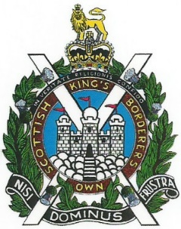

Mobile: 07735475123
Email: fredleith@hotmail.co.uk or perry.leith517@mod.gov.uk

KOSB GOLF OUTING MAGDALENE FIELDS GOLF CLUB FRIDAY 29th July 2022

- The annual all ranks KOSB golf meeting will take place at Magdalene Fields Golf Club, Berwick-upon-Tweed TD15 1NE on Friday 29th July 2022.

- Format -18 holes Stableford, first tee off time will be 08:30 therefore please arrive in plenty of time for breakfast, briefing and a photograph prior to play. The handicap will be capped at 18 unless you can provide proof with a handicap certificate from your home golf club.

- Prizes will be awarded as for the following holes, please be mindful that to keep if fair to everyone, only one prize will be awarded per golfer.
- Best Stableford Score
- Best Scratch Score
- Longest Drive
- Nearest the pin on all par 3s
- 2s pot on the day if you want to participate

- Eligibility KOSB association members of all Ranks and invited guests.

- The cost for the day is £40 for association members and for guests his includes green fees, (18 holes) bacon roll and coffee on arrival and high tea at the end of play. If you are bringing a caddie you will need to pay for their meal on the day separately, please inform the golf club on the morning of play.

- All payments by internet banking to the following:
Account Name KOSB Golf
Sort code 80-45-94
Account number 11618669

- Dress- normal golfing attire on the course and in the club house.

- This event is being organised to coincide with the Minden weekend activities and it is hoped that we have a good turn out like previous years, thank you for supporting this event. One final plea if you know any Borderer’s that would like to play, please pass the word around not everyone is on the internet or has access to social media, this is a good opportunity to add to the Regimental calendar and can only be a success with maximum participation.

- If you have any issues, please contact myself, numbers and Email at the top of this page or Arthur Neil artneilxxv@outlook.com mobile 07854407281.

ONCE A BORDERER ALWAYS A BORDERER

